Part 2.1: What's the difference?

- What are the two types of Intents?
  - The two type of intents are explicit intent and implicit intent
- Which of the two types of Intents are more secure?
  - Explicit intent is more secure. Implicit its insecure because you dont know what service will respond to the intent
- What type of Intent is shown on lines 69 to 73 of SecondFragment.kt?
  - Below is a screenshot showing the code in lines 69 to 73 of the SecondFragment.kt. The type of intent is Implicit intent un the code below the component/context is not being specified

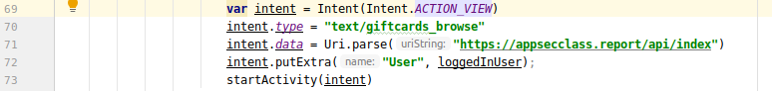

- What type of Intent is shown on lines 68 to 70 of ThirdFragment.kt?
  - Below is a screenshot showing the code in lines 68 to 70 of the ThirdFragment.kt. The type of intent for the code below is Explicit intent. In the code the component/context is being specified and the external class to be invoked is defined

- Which of these two Intents is the proper way to do an Intent?
  - The proper way is to use explicit intent because explicit intents are used in the application itself to switch between activities. I modified the code SecondFragment.kt to make it similar to the code in ThirdFragment.kt
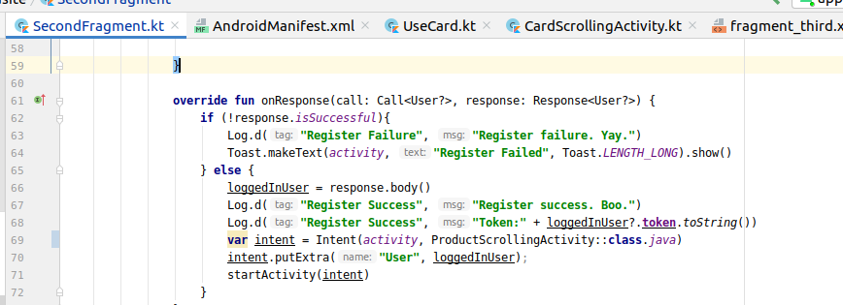

Part 2.2: Shutting out the world
In order to remove the possibility of other applications using intents to launch activities of the application I first removed the launcher category inside the intent filter in the AndroidManifest file. I noticed that Android Studio generated an error. Then I removed all the lines with <intent-filter> and </intent-filter> from the file but again another error was generated when I compiled the project.
After more research about intents in the Android Manifest file I noticed the mention of the action “VIEW” can be used to open other apps. Therefore, I removed the line of code: <action android:name="android.intent.action.VIEW" /> from every activity in the android manifest file

Part 3: Can you read me out there?
I modified the following the following code line below from http to https:
var builder: Retrofit.Builder = Retrofit.Builder().baseUrl("http://appsecclass.report").addConverterFactory(GsonConverterFactory.create()) by

var builder: Retrofit.Builder = Retrofit.Builder().baseUrl("https://appsecclass.report").addConverterFactory(GsonConverterFactory.create()) by
I modified all the code lines that reference the website in the following files:
- ThirdFragment.kt
- CardScrollingActivity.kt
- ProductScrollingActivity.kt
- UseCard.kt
- GetCard.kt
- CardRecyclerViewAdapter.kt
- RecyclerViewAdapter.kt

Part 4: Oops, was that card yours?
I believe that manipulating the code line “card?” can be use to allow users to GiftCards that do not belong to them. The attacker can use that to select a card that belongs to another user.
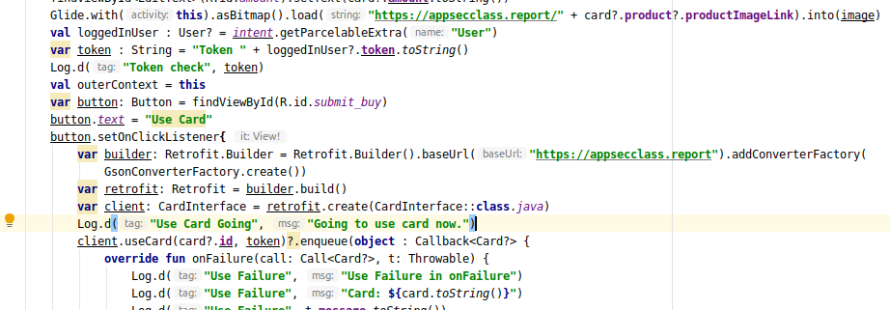

Part 5: Privacy is Important

You should remove all necessary code in the following files:
- AndroidManifest.xml
I removed the following code from the file:
<uses-permission android:name="android.permission.ACCESS_FINE_LOCATION"/>
<uses-permission android:name="android.permission.ACCESS_COARSE_LOCATION"/>

- UserInfo.kt
I removed the following code from the file:

@POST("/api/metrics")

- CardScrollingActivity.kt

I removed the following code from override fun OnCreate(savedInstanceState: Bundle?)

val locationPermissionCode = 2
var locationManager = getSystemService(Context.LOCATION_SERVICE) as LocationManager
if ((ContextCompat.checkSelfPermission(this, Manifest.permission.ACCESS_FINE_LOCATION) != PackageManager.PERMISSION_GRANTED)) {
ActivityCompat.requestPermissions(this, arrayOf(Manifest.permission.ACCESS_FINE_LOCATION), locationPermissionCode)
}
locationManager.requestLocationUpdates(LocationManager.GPS_PROVIDER, 5000, 5f, this)
sensorManager = getSystemService(Context.SENSOR_SERVICE) as SensorManager
mAccel = sensorManager.getDefaultSensor(Sensor.TYPE_ACCELEROMETER)

I also removed the following functions:

override fun onResume() {
super.onResume()
mAccel?.also { accel ->
sensorManager.registerListener(this, accel, SensorManager.SENSOR_DELAY_NORMAL)
}
}
override fun onPause() {
super.onPause()
sensorManager.unregisterListener(this)
}

- ProductScrollingActivity.kt
I removed the following code from override fun OnCreate(savedInstanceState: Bundle?)

val locationPermissionCode = 2
var locationManager = getSystemService(Context.LOCATION_SERVICE) as LocationManager
if ((ContextCompat.checkSelfPermission(this, Manifest.permission.ACCESS_FINE_LOCATION) != PackageManager.PERMISSION_GRANTED)) {
ActivityCompat.requestPermissions(this, arrayOf(Manifest.permission.ACCESS_FINE_LOCATION), locationPermissionCode)
}
locationManager.requestLocationUpdates(LocationManager.GPS_PROVIDER, 5000, 5f, this)
sensorManager = getSystemService(Context.SENSOR_SERVICE) as SensorManager
mAccel = sensorManager.getDefaultSensor(Sensor.TYPE_ACCELEROMETER)

I also removed the following functions:

override fun onResume() {
super.onResume()
mAccel?.also { accel ->
sensorManager.registerListener(this, accel, SensorManager.SENSOR_DELAY_NORMAL)
}
}
override fun onPause() {
super.onPause()
sensorManager.unregisterListener(this)
}

